**SY B.Tech - Applied Mathematics**

**Programming Assignment no.**: **3**

**Name of student: Dhiraj Vaibhav Bagul**

**Branch & Block: B3 , B32**

**Cycle No. : 1**

**Roll No. : 324**

**Problem Statement:**

1. An investigator has reported the data tabulated below for an experiment to determine the growth rate of bacteria k (per d), as a function of oxygen concentration c (mg/L). Find which degree of polynomial is the best fit for given data using MATLAB. (324)

|  |  |  |  |  |  |
| --- | --- | --- | --- | --- | --- |
| c (mg/L) | 0.5 | 0.8 | 1.5 | 2.5 | 4 |
| k (per d) | 1.1 | 2.4 | 5.3 | 7.6 | 8.9 |

Plot the best fit curve by continuous line along with the given data points by ‘o’ on the same graph. Print the equation on command prompt after getting the coefficient.

**Algorithm (Logical understanding of the problem):**

1. Start
2. Taking the values from the provided problem statement (c = [0.5 to 4] , d = [1.1 to 8.9] )
3. Finding the constants involved in the relation using polyfit .
4. Using variable ‘p’ to store the values of the constants .(considering the linear equation for curve fitting as best fit )
5. Taking set of values c1 ( c1 = [0 to 10] )
6. Finding the corresponding values of the k1 using polyval function .
7. Plotting the curve using plot function.
8. If best fit is not obtained using linear equation then using basic fitting option to find best fitting polynomial expression for given problem and modifying step 4.(in rhis case the bestfit expression was forth degree polynomial.)
9. End

**Code in MATLAB:**

clear all ;

close all ;

clc ;

%declaring the variables and their values in a column matrix

c = [0.5 0.8 1.5 2.5 4] ;

k = [1.1 2.4 5.3 7.6 8.9] ;

%finding the values of constants in the polynomial expressions

p1 = polyfit(c,k,4) ;

%taking the range of c to substitute in

c1 = 0 : 0.1 : 6 ;

%finding the values of the k using bestfit expression

k1 = polyval(p1,c1) ;

%displaying the plot

plot(c,k,'o',c1,k1)

xlabel('c (mg/L)')

ylabel('k (per d)')

title('Assignment 1 : growth rate of bacteria')

disp('Polynomial expression is : ')

%displaying the best fit polynomial equation for data

disp('y = p1*c1^4 + p2*c1^3 + p3*c1^2 + p4*c1 + p5') ;

%displaying constants

disp('The valus of constants are')

p1 = polyfit(c,k,4)

**Output of program:**

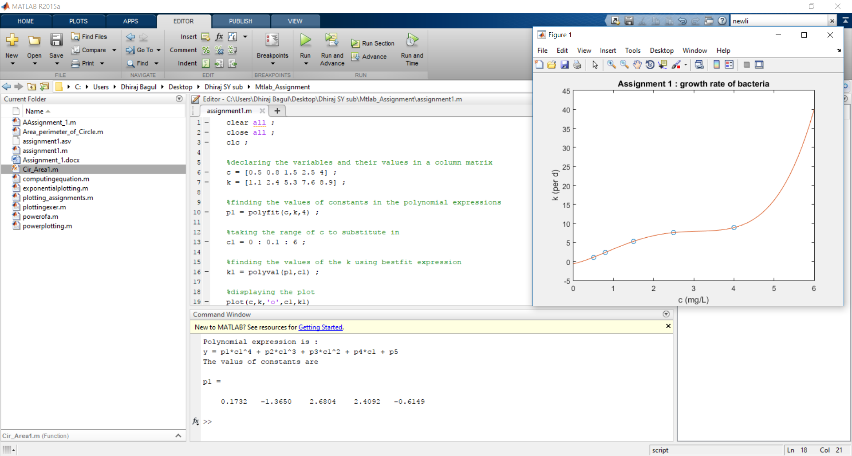

**Reporting of errors and debugging:**

1. >> AAssignment_1 Error: File: AAssignment_1.m Line: 11 Column: 8 The expression to the left of the equals sign is not a valid target for an assignment. **Solution:** correction in writing the expression.
2. >> assignment1 Error using ^

Inputs must be a scalar and a square matrix. To compute elementwise POWER, use POWER (.^) instead.

**Solution**: use (.^) operator to take power of elements in the matrix and avoid using ^ to do this Which represents the matrix multiplication of itself.

1. >> assignment1 Error: File: assignment1.m Line: 19 Column: 26 The expression to the left of the equals sign is not a valid target for an assignment.

**Solution**: proper use of title function writing the title in single inverted comma , rather than using double inverted commas.